

SCS4124 - FINAL YEAR PROJECT IN COMPUTER SCIENCE

INTERIM REPORT

ORIGINAL TITLE

MODELING SITUATED COGNITION IN REACTIVE ROBOTIC ARCHITECTURE

REVISED TITLE

MODELING SITUATED COGNITION IN REACTIVE ROBOTIC ARCHITECTURE USING A NEURO-FUZZY COMPUTATIONAL APPROACH

By

………………………

N. N. Padukka

Supervised by

………………………

Dr. H. I. Ekanayake

Senior Lecturer

University of Colombo School of Computing

**Abstract**

Robots based on conventional AI architectures were often failed to act in unstructured environments specially the structure of the objects located in the environment is unknown. This is due to the unpredictability of interactions that are made by the robot with the environment. As an alternative to this approach, situated robotic architectures were emerged. Situated robotics is the study of robots embedded in complex, often dynamically changing environments. Situated robotics were significantly influenced by reactive robotic paradigm which is inspired by studies of ethology. Subsumption architecture is one such kind of situated robotic architecture which was succeeded in real world environments.

This research focuses on modeling a situated reactive robotic architecture. Research will be carried out in two parts. In first part of the research, enhancing the situatedness of reactive robotic architecture will be considered. Situatedness refers to the fact that to which extent agent’s cognitive process is affected by its environment. In this research, how agent’s behavior can be affected by its internal and external environments are taken into consideration. Fuzzy controller based approach will be used to interface selected internal and external environmental variables to the existing reactive robotic architecture.

In second part of the research, implementing a situated cognitive architecture using neural dynamics will be carried out. Situated cognition is a theory which emphasizes that “agent’s knowledge is constructed within and linked to the activity, context, and culture in which it was learned” [4] [5]. Agents construct a new representation in their brain with every interpretation they made. This situated cognitive architecture will be implemented using dynamic field theory. Dynamic Field Theory is a framework implemented using neural dynamics. This architecture will be interfaced with internal and external environmental variables using the same approach as in the first part. The resulting system will be a neuro-fuzzy hybrid system.

This report details the project aims, research questions, background, methodology, research design, preliminary results, scope and delimitations. This document also provides a schedule of the project, including a description of current progress.

Table of Contents

Chapter 1 1

1.1. Introduction 1

1.1. Interpretations 2

1.1.1. Situatedness 2

1.1.2. Embodiment 2

1.1.1. Situated Cognition 2

1.2. Statement of the problem 3

1.3. Project goal and objectives 3

1.4. Research questions 4

1.5. Research Methodology 4

1.6. Scope and Delimitations 5

1.7. Significance of the research 5

1.8. Project Timeline 6

Chapter 2 7

1. Literature review 7

1.1. Robotic Paradigms 7

1.2. Subsumption architecture 8

1.3. A neural-dynamic architecture for behavioral organization of an embodied agent 9

1.4. Cognitive affective architecture 9

2. Design 11

2.1. Design Assumptions 11

2.2. Goal of the robot 11

2.3. Robotic Architecture 12

2.3. Design of the Robot 14

3. Preliminary results & discussion 15

References 18

**List of Abbreviations**

AI Artificial Intelligence

DFT Dynamic Field Theory

EB Elementary Behavior

ICEA Integrating Cognition, Emotion and Autonomy

AFSM Augmented Finite State Machine

IR Infrared

PID Proportional Integral Derivative

CoS Center of Satisfaction

**Table of Figures**

Table 1: Project Timeline 6

Figure 1: Convolutional AI robotic control 7

Figure 2: Battenberg’s vehicle [11] 8

Figure 3: Reactive Paradigm [10] 8

Figure 6: Cognitive affective architecture schematic involving different level of homeostatic regulation and behavioral organization in robotic agents [13] 10

Figure 7: Goal of the robot 11

Figure 8: Coupling Elementary Behaviors [12] 13

Figure 13 : Implemented Robot 15

Figure 14: Architecture of the obstacle avoidance robot 15

Figure 15: ACS712 Current Sensor 17

Figure 16: DH11 temperature and humidity sensor 17

# Chapter 1

## Introduction

One of the most challenging problems faced by researchers in Artificial Intelligence(AI) is having artificial agents to interact with their environment, specially the structure of the environment is unknown. Using traditional AI approaches, researchers have attempted to find a solution for this by endowing the systems with more complete and flexible models of the world [1]. Due to the unpredictability of interactions, traditional AI technologies started to face intractable issues when confronted with real-world modeling problems.

In order to address these issues, another approach to decisional AI, also known as situated or behavioral AI, has been proposed. Situated approach builds agents that are designed to behave effectively successfully in their environment. The goal of situated AI is to model entities that are autonomous in their environment. This requires designing AI from the bottom-up by focusing on the basic perceptual and motor skills required to survive. Rodney Brook’s subsumption architecture is an extremely popular situated robotic architecture and it allows the successful creation of real-time dynamic systems that can run in complex environments.

This research is focusing on modeling a situated cognitive reactive robotic architecture. This research will be carried out in two parts. In first part of the research, enhancing the situatedness of reactive robotic architecture will be considered. Situatedness means that to which extent agent’s cognitive process is affected by its environment. Situatedness also depends with the internal and external environmental conditions of its situated environments which was not taken much attention in previous researches. In this research one of our goals is to take this into consideration and enhance the situatedness of reactive robotic architecture by integrating internal and external environment conditions into cognitive process. As the internal environment variable, energy level of the agent will be considered. Temperature will be considered as the external environment variable. A fuzzy controller based approach will be used to interface these two variables into the cognitive process.

In second part of the research, implementing a situated cognitive architecture using neural dynamics will be carried out. Many cognitive scientist and AI researchers nowadays consider situated cognition as the main sub piece of any form of true intelligence, natural or artificial [2]. “Situated cognition is a theory which emphasizes that people’s knowledge is constructed within and linked to the activity, context, and culture in which it was learned” [4] [5]. The idea of situated cognition first appeared in the psychological research studies and latterly adapted into artificial cognitive systems [4]. It explains how human brain constructs a new representation in their brain with every interpretation they made. Agent learns from every interaction they made either physically, socially or culturally. Situated cognition understands memory as an interaction with the world, bounded by meaningful situations. In situated cognitions, knowledge is not an entity or symbols, knowledge is an action. This can be considered as a known behavior. Developing an interaction with the environment, doing the same action again and again considered as learning in situated cognition [3].

It’s not an easy task to completely replicate the situated cognition into machines. Over the years, many researches have been conducted to model situated cognition into artificial agents. This research is a step towards modeling situated cognition to reactive robotics which will contribute to the whole process.

Dynamic Field Theory is a framework implemented using neural dynamics to model situated and embodied cognition. This situated cognitive architecture will be implemented using dynamic field theory. This architecture will be interfaced with internal and external environmental variables using the same approach as in the first part. The resulting system will be a neuro-fuzzy hybrid system.

## Interpretations

Situated cognition, situatedness, embodiment are concepts that are initially emerged in cognitive science and latterly adapted into other research domains. There are no universal definitions interpreted across all research domains. Therefore, these concepts will be explained and interpreted in this section.

### 1.1.1. Situatedness

Situatedness means that agent is existing in a complex environment and cognitive process is strongly affected by its environment. Agents which are closely coupled to the physical environment are called physically situated agents [6]. Agents which are capable to acquire information about the social and cultural domains through its surrounding environment are categorized as socially and culturally situated agents [6]. Situatedness is commonly applied to both natural and artificial agents. The main difference between the natural and artificial agents depends on social and cultural situatedness of the agent. In this research, enhancing the physical situatedness of artificial intelligent agents will be considered. How an agent’s behavior is affected by its environment will be addressed in this research.

### 1.1.2. Embodiment

Embodiment is a concept related to situatedness. The robots have bodies and experience the world directly. Their actions are part of a dynamic with the world, and the actions have immediate feedback on the robots' own sensations [7]. In behavior-based robotics (Brooks, 1999), the complexity of behavior is due to a combination of embodiment and situatedness. Embodiment is the degree to which a robot can affect its environment [8].

### Situated Cognition

“Situated cognition is a theory which emphasizes that people’s knowledge is constructed within and linked to the activity, context, and culture in which it was learned” [4] [5]. People construct a new representation in their brain with every interpretation they made. William Clancy claims that, “situated cognition is that perception and action arise together, dialectically forming each other” [3].

Most of human behaviors can be considered as situated actions because behaviors including speech, problem-solving, and physical skills, are generated on the fly, not by mechanical application of scripts or rules previously stored in the brain [6]. Situated cognition gives this ability of human beings to thinking on the fly rather than the storage and retrieval of conceptual knowledge.

In this research as situated cognition, how robot makes decisions to change the behavior according its perceptions and its previous knowledge will be addressed.

## Statement of the problem

This section describes the research gap that is expected to address in this research. It also explains the expected contribution to the research domain.

Situatedness refers to the fact that to which extent agent’s cognitive process is affected by its environment. Situatedness also depends with the internal environment conditions like energy level. Internal environmental parameters of the agent were not considered in modeling existing reactive robotic architectures. In this research, energy level was taken as an internal environmental parameter. In this robotic architecture, energy level will be given as an input parameter to the system. Energy level will affect the cognitive process of situated robot in the proposed architecture.

External environmental conditions like temperature indirectly affect the situatedness of an agent. In previous researches, this has not been taken much attention. In this research, temperature will be considered as an external environment parameter. Temperature of the environment will affect the cognitive process of this proposed architecture.

The existing reactive robotic architectures deviate from bio-inspired implementations. Since human behavior is based on human nervous system, implementations of situatedness should be carried out using neurology based implementation. In this research, behavior based reactive robotic architecture will be implemented using neural dynamics.

## Project goal and objectives

Due to the complexity of natural intelligence, it is not an easy task to completely model natural intelligence to robots. Therefore, capabilities of intelligent systems should be incrementally implemented. Over the years, there have been many research attempts to model natural intelligence for robotics. In recent researches in cognitive science, researchers claim that situated cognition as a main component of behavior based natural intelligence. The main aim of this research project is to propose a conceptual level reactive robotic architecture which extends the situatedness of reactive robotics using computationally plausible methods.

**Objectives**

* Propose a behavior based reactive architecture using neural dynamics
* Determine the strength of behaviors using fuzzy integrations to propose behavior based reactive architecture
* Implement a robot based on the neuro-fuzzy hybrid architecture to function in a real-world scenario
* Evaluate the performance of the proposed architecture

## Research questions

**RQ1: How to enhance the situatedness of robots by incorporating both internal and external features of its situated environment using fuzzy integrations?**

Internal features are features that are directly related to the situated task like energy level. External features are features that are indirectly and ubiquitously related to the situated task like temperature, social presence, light, air, and sound conditions. According to the internal and external environment conditions, strength of the behavior should be changed. In this research, the question “How to incorporate these parameters to behaviors using fuzzy integrations?” will be answered. This can be also used to enhance the internal energy management features of reactive robotics by introducing energy saving behaviors.

**RQ2: How to naturalize the reactive robotic architecture with neurologically plausible computational approach**?

Although reactive robots are implemented based on biological behaviors of animals like insects, the existing reactive robotic architectures deviate from bio-inspired implementations. Since natural intelligence is based on a neuron system, implementations of situatedness should be approached using neurology based implementation.

## Research Methodology

It is important to note that, in modeling behavior based situated robotics, *Dynamic Filed Theory* which is neural dynamic framework for sensory-motor applications has given better results in recent researches [12]. In our research, this neural dynamic framework will be used to find the desired behavior to achieve the goal. Even though it is possible to find the desired behavior using neural dynamics, other internal and external environment conditions affect the strength of the behavior. These internal and external factors which are not directly related to goal seeking also considered in this architecture. In this research approach temperature will be considered as the external environment condition while considering energy level as the internal condition. After finding the desired behavior using neural dynamics, based on the other internal and external environmental conditions the strength of the behavior will be determined using fuzzy integrations. Hence, the resulting system will be a neuro-fuzzy hybrid system. The below section explains the research approach in a more structured manner.

**Phase I - Complete the structure of the robot**

In this phase, completing the structure of the robot, assembling the sensory-motor parts, interfacing circuits will be carried out.

**Phase II - Implement the subsumption architecture using python threads on raspberry pi**

In this phase, subsumption architecture based obstacle avoidance robot will be implemented using python threads and tested.

**Phase III - Integrate fuzzy controllers to behaviors with energy level and temperature**

In this phase, to incorporate energy level and temperature to the behaviors, a fuzzy controller will be designed and implemented.

**Phase IV - Replace subsumption architecture with neural dynamic architecture**

In this phase, behavior based reactive robotic architecture using neural dynamics will be implemented and subsumption architecture will be replaced from the proposed architecture. The resulting system will be a neuro-fuzzy hybrid system.

**Phase V - Integrate computer vision**

In this phase, computer vision will be integrated to the robot to find the lines and avoid obstacles more accurately.

## Scope and Delimitations

This section describes the scope of the project and delimitations. This research project will be carried out in two main parts. In the first part of the research, enhancing the situatedness of reactive robotic architecture by incorporating internal and external environmental conditions will be carried out. External conditions are environmental conditions that are indirectly and ubiquitously related to the situated task like temperature, social presence, light, air, and sound conditions. Internal conditions can be energy level, processing power etc. In this research, our scope is limited to address the cognitive process of the robot with energy level and temperature of the robot.

In second part of the research, implementing a situated cognitive architecture using neural dynamics will be carried out. Objects in the robot arena will be a selected set of objects and only the location of these objects in the environment can be changed. When the positions of the objects are changed, robot should be still able to complete the goal.

There are learning methods like reinforcement learning, instar leaning, available in dynamic field theory framework. In our scope learning methods will not be considered. A predefined activation field will be used to find the activated behavior.

## Significance of the research

* **Robot autonomy in unknown environments**

If we could be able to model the proposed architecture, it can be used to implement robots which can function in unknown environments.

* **Human-Robot relationship**

This research will be a step towards modeling an important capability of human intelligence. This research will help to build human alike robots in future. It helps to increase the human-robot relationship.

* **Cognitive replacements for human in future**

In future, if researchers could be able to build completely intelligent robots, it will help to reduce the work load of human being.

* **Adaptive robotics**

If we could be able to address latent features such as energy level of robot it will be a contribution towards adaptive robotics

## Project Timeline



**Completed To be completed**

#### Table 1: Project Timeline

# Chapter 2

## 1. Literature review

### Robotic Paradigms

A paradigm is a philosophy or set of assumptions and techniques which characterizes an approach to a class of problems [10]. Robotic paradigm can be described by the relationship between sense, plan and act. Currently there are three paradigms for organizing intelligence in robots - Hierarchical, Reactive, and Hybrid Deliberative/Reactive.

**Hierarchical Paradigm**

The Hierarchical Paradigm is the oldest paradigm used in robotic design and it works in three stages. In Hierarchical Paradigm, the robot senses the world, plans the next action, and then acts as shown in the figure 1. At each step, the robot explicitly plans the next move. This works similarly to a traditional computer program that models isolated input, output systems. When using this model roboticists face following two problems.

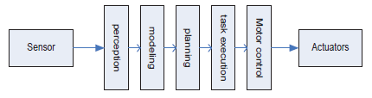

#### Figure 1: Convolutional AI robotic control

* **Frame problem**

The problem of representing a real-world situation in a way that was computationally tractable became known as the frame problem [10].

* **Closed world problem**

Roboticists claim that robot must function in the open world. It means robot should be able to function in an unknown environment [10].

**Reactive robotic paradigm**

To address the Frame Problem and Closed world problem roboticists proposed a new paradigm based on animal behaviors. Animals living in open world and simple animals such as insects, fish and frogs who exhibit intelligent behaviors without a brain were the motivation for considering animal behaviors.

Figure 2 shows Battenberg’s vehicle, consists of a sensory system, motor systems, a nervous system and a body. These vehicles have two light sensors mounted in front and these sensors are directly coupled with motors. As figure illustrates, vehicle 2a moves away from light source and robot 2b moves towards the light source. This Battenberg’s vehicle can be considered as the first steps towards reactive paradigm [11].



#### Figure 2: Battenberg’s vehicle [11]

Reactive paradigm is a sense-act type of organization. The robot has multiple instances sense-act couplings. These couplings are concurrent processes, called behaviors. Figure 3 shows how multiple behaviors works concurrently in reactive paradigm [10].

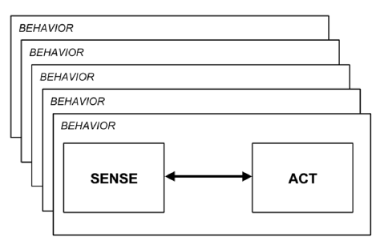

#### Figure 3: Reactive Paradigm [10]

### Subsumption architecture

Brook’s Subsumption architecture can be considered as the first situated robotic architecture. The robots built using the Subsumption architecture were the first to be able to walk, avoid collisions, and climb over obstacles. A behavior in the Subsumption architecture is a network of sensing and acting modules which accomplish a task.

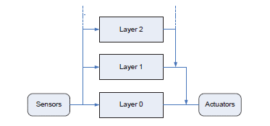

**Figure 4: Subsumption Architecture [20]**

A module at a higher level can suppress the input of a module at a lower level thereby preventing the module from seeing a value at its input. A module can also inhibit the output of a module at a lower level thereby preventing that output from being propagated to other modules.

The modules are augmented finite state machines (AFSM), or finite state machines which have registers, timers, and other enhancements to permit them to be interfaced with other modules. An AFSM is equivalent to the interface between the schemas and the coordinated control strategy in the behavioral schema.

Subsumption architecture is an important milestone in artificial intelligence robots. This was the first robot which could walk, avoid collisions, and climb over obstacles in open environment. Recent works suggest that when adding higher layers, behavior of robot deviate from biological behaviors. In Subsumption architecture, behaviors are organized in prioritized manner and robot cannot perform multiple behaviors at a time. Another factor is that, even though Subsumption architecture is bio-inspired, implementation of Subsumption architecture is different from neurological aspects. Internal states such as energy level of robot has not been addressed in Subsumption architecture.

### A neural-dynamic architecture for behavioral organization of an embodied agent

In this work, researchers have presented a neural-dynamic based behavior based robot using NOA experimental robot which can gasp a cup using robot arm. This architecture is very specific to task and has following behaviors; find color- find the blue color cup, move-end effecter – move the robot arm to the location, open gripper and close gripper. They have used Dynamic Filed Theory (DFT) for the neural dynamic implementation [12].

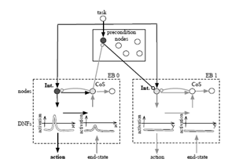

**Figure 5: Coupling two elementary behaviors**

### Cognitive affective architecture

Figure 6 shows the work of the larger European cognitive robotics group called ICEA. This is an abstract model of the hypothalamus and brainstem which deal with ‘low-level mechanisms’ of human body such as drives and bio-regulations. The primary aim of this research to computationally model, at different level of abstraction, different brain structures and their interactions [13].

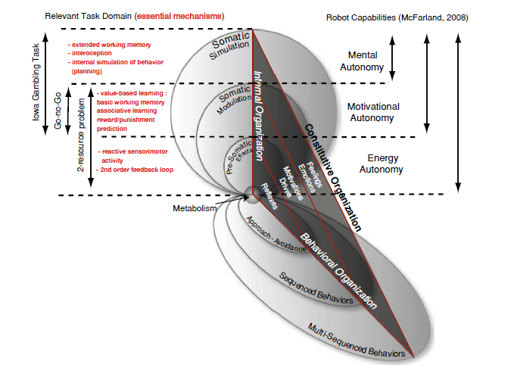

#### Figure 6: Cognitive affective architecture schematic involving different level of homeostatic regulation and behavioral organization in robotic agents [13]

******************

## 2. Design

This section provides the design of the project. It details the design of the neuro-fuzzy based reactive robotic architecture and the design of the robot that will be made on the proposed architecture. The proposed methodology focuses on enhancing the situatedness of reactive robotic architecture using fuzzy integrations and proposes a behavior based situated cognitive architecture using neurologically computational approach. The basic design approach can be divided into four parts. The first part is enhancing the situatedness of reactive robotic architecture using fuzzy integrations. The second part is proposing a behavior based situated cognitive architecture. The third part of the research is to integrate situated cognitive architecture with fuzzy controller based implementation of the first part of the research, which will lead to a neuro-fuzzy hybrid system. The final part is implementing a simple robot based on the hybrid architecture.

### 2.1. Design Assumptions

This section provides the design assumptions that have been identified as follows;

* As the internal environmental condition of the robot, only the energy level of the robot will be considered
* As the external environmental condition, only the temperature of the environment will be considered
* For the testing purposes, robot will be designed to react to slight variation of the temperature

### 2.2. Goal of the robot

This section explains the goal of the ultimate robot which will be implemented using the proposed architecture.

Goal of the robot is to reach to the target location, by following a path which has obstacles and discontinuities among the path, while utilizing the available energy and attending awareness to the temperature. Initially, the distance from start to the target location will be given as an input to the robot. Wheel encoders will be used to find the traveled distance and remaining distance will be calculated by reducing the total distance from current distance. Figure 7 shows the map of the robot arena which has obstacles, and line discontinuities among the path.

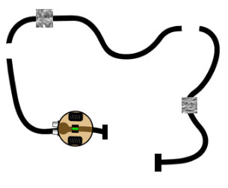

#### Figure 7: Goal of the robot

### 2.3. Robotic Architecture

In this section, architecture of the proposed neuro-fuzzy based reactive robot will be explained.

**Design of Behavioral Reactive Robotic Architecture**

As explained in the literature review section, behavioral robots are implemented using elementary behaviors. These behaviors take control over the other behaviors according to the current requirement. All these behaviors are acting towards the completion of the task. In this, research the main goal has been divided into four elementary behaviors as follows.

1. **Obstacle Avoidance Behavior**

Obstacle avoidance behavior is an algorithm to provide the ability of the robot to avoid any kind of obstacles to prevent collision. The obstacle avoidance mode is defined as when any of the front distance sensors detects obstacles.

1. **Path Following Behavior**

Path following behavior is an algorithm to navigate the robot along the path using its IR sensors. It works by adjusting the speed of the motors to remain in the desired path with distance. PID controller will be used to maintain the smoothness of movement of the robot.

1. **Line Finding Behavior**

When path discontinuity occurs, this behavior should get activated and robot should move randomly across the arena to get back into the path.

**4) Finding the Target Behavior**

Finding the target behavior is the verification layer of the localization system. In this part, a camera will be used to verify the robot position. The vision subsystem can use trained objects to localize where the robot is located.

In this research, each elementary behavior will be implemented using dynamic field theory. For each elementary behavior, there is a dynamic neural activation field called Center of Satisfaction (*CoS*) [12]. This CoS field detects a match between the inputs it receives from the intention dynamic neural field and the perceptual inputs [12]. The match is detected when the perceptual input correspondence to the expected intention field of the behavior. When CoS get activated, it inhibits the intention of the EB to transition to another elementary behavior by suppressing the current behavior. Intention field can be a trained input field or a predefined activation field. It works same as suppressing a behavior by another behavior and taking control in subsumption architecture.

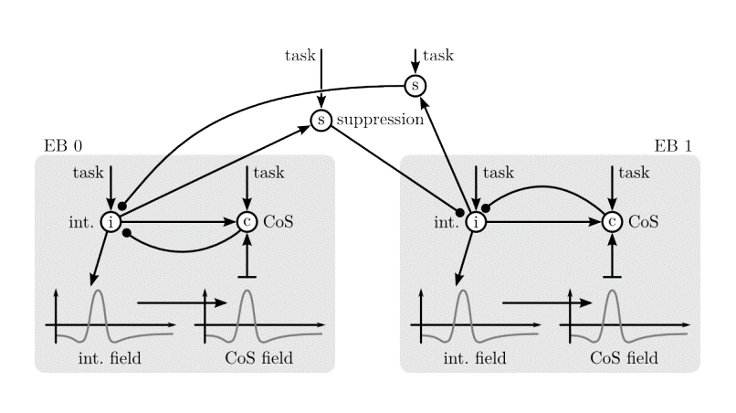

#### Figure 8: Coupling Elementary Behaviors [12]

In this research, above mentioned four behaviors will be implemented using DFT framework. There is a C++ library available to implement behaviors. The intention fields can be given as a predefined set of parameters or can be trained using learning methods such as instar learning and reinforcement learning [10].

**Design of the Fuzzy Controller**

As explained in the previous sections, to enhance the situatedness of the behavior based architecture, energy level and temperature of the robot will be considered. In order to integrate these variables into decision making process, each behavior will be interfaced with a fuzzy controller.

Inputs to the fuzzy controller will be energy level, temperature and remaining distance. Based on these parameters, the strength of the currently active behavior will be altered to achieve the final goal.

**Rule evaluation**

In the rule evaluation stage, based on fuzzy rules and input variables (temperature, energy), value of the output variable (motor speed) will be determined. For each behavior, rules should be designed to achieve the goal while utilizing the remaining energy and keeping attention to the temperature. Behavior also should depend with the temperature. Fuzzy rules should be implemented while testing the performance of the robot, at this level it’s not possible to derive exact rules that will be used in implementing.

**Defuzzification**

In Defuzzification stage, output from the rule evaluation stage will be mapped to the motor speeds of the robot.

**Resulting Neuro-fuzzy hybrid system**

Figure 12 shows the resulting neuro-fuzzy hybrid system after integrating the neural dynamic architecture with fuzzy controller.

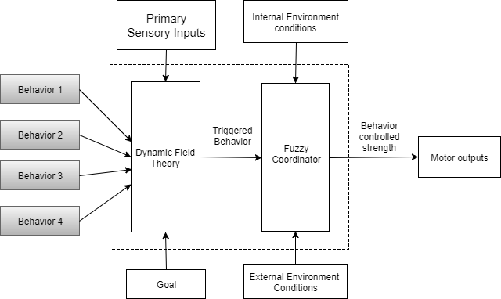

**Figure 12: Resulting Neuro-fuzzy hybrid system**

### 2.3. Design of the Robot

The robot control board is a Raspberry pi 2 B board which runs on the Raspbian operating system. Ultrasonic sensor with rotating capabilities will be used to detect obstacles. DH11 temperature is used to measure the temperature. ACS712 and a voltage divider circuit is used to measure the current usage and voltage level of the battery. A 4000mAh battery is used to energize the whole system.

**Calculating the remaining energy level**

This function will be used to calculate the remaining energy level in the battery.

## 3. Preliminary results & discussion

Completing the structure and assembling the hardware component of the robot were completed. Robot is now in working condition and has the compaility to program via a putty connection. Therefore, Phase-I of the project is already completed. Figure 13 shows the implemented robot. This robot has the capabilty to find obstacles and avoid them, measure temperature and energy level. It also has the wireless connectivity.

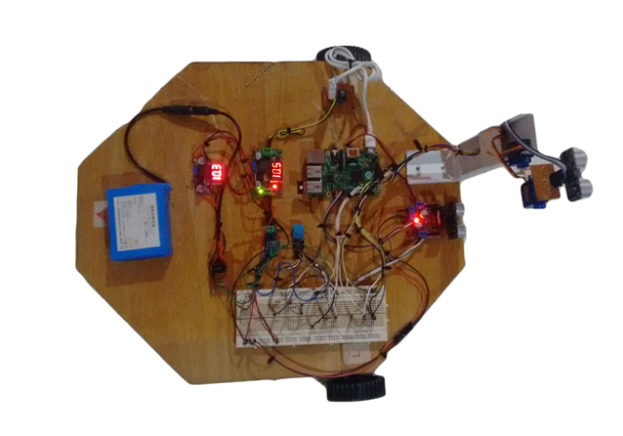

#### Figure 13 : Implemented Robot

All the basic functionalities like motor driving, scanning obstacles and locating the object direction, reading temperature sensors, and meassuring power have been programmatically implemented using python and tested. To detect obsctacles, ultra sonic sensor is rotating across 1800 angle and taking measurement in for every 100 intervals.

Currently, phase II of the project is being carreied out. In order to complete the phase II, subsumption architecture based obstacle avoiding robot should be implemented. Bottom layers of the obstacle avoidance robot subsumption architecture were implemented and these two layers, simultaniously run in two different python threads. Figure 14 shows the implemented layers of the robot.

Moving forward

Obstacle Avoidance

#### Figure 14: Architecture of the obstacle avoidance robot

In this architecture, obstacle avoidance has the priority over moving forward behavior. Obstacle avoidance behavior can suppress the moving forward behavior and take control to avoid the obstacle when the robot met an obstacle. Layers are implementing in the bottom-up approach and wandering, map building layers have to be implemented.

**Implementation of Obstacle avoidance behavior**

**Pseudo Code:**

***Take Control:***

*function takeControl(){*

*readsonar()*

*if (distance_m30< 30 or distance_0 <30 or distance_30 <30):*

*print "Obstacle Avoidance Taking Control"*

*return True*

*}*

***Suppress:***

*function suppress () {*

*suppressed=True;*

*}*

***Action:***

*function action () {*

*print "Obstacle avoidance processing"*

*if (obstacle in left side = false) {*

*Change direction to left*

*}*

*Else if (obstacle in right side = false) {*

*Change direction to right*

*}*

*Else {*

*Turn 1800 degrees*

*}*

*}*

**Measuring Temperature and Energy Level**

DH11sensor module is being used to measure the temperature in the environment. An ACS712 current sensor is being used to measure the current consumption of the robot. Using the temperature and voltage level, power consumption can be calculated. This will be used to calculate the energy level of the robot.

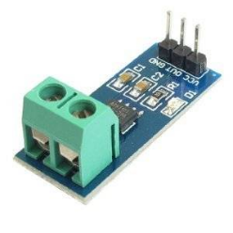

#### Figure 15: ACS712 Current Sensor

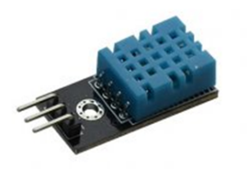

#### Figure 16: DH11 temperature and humidity sensor

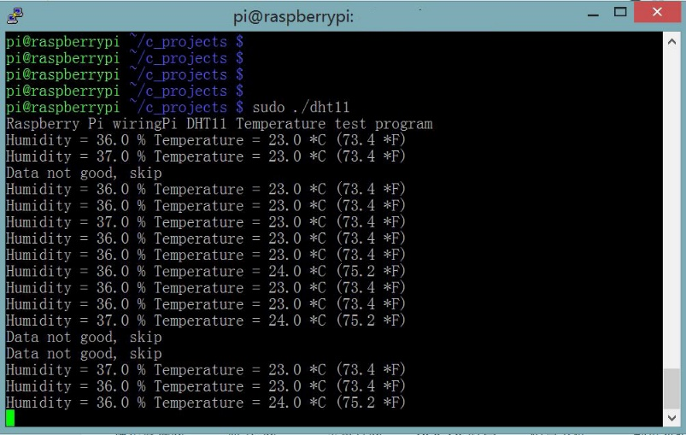

**Figure 17: Temperature readings**

**\*\*\*\*\*\*\*\*\*\*\*\*\*\*\***

# References

[1] Brooks, Rodney A. "Intelligence Without Representation". Artificial Intelligence 47.1-3 (1991): 139-159. Web.

[2] Ziemke, Tom, and Robert Lowe. "On the Role of Emotion in Embodied Cognitive Architectures: From Organisms To Robots". Cognitive Computation 1.1 (2009): 104-117. Web.

[3] Clancey,W.J. (1995). A boy scout, Toto, and a bird: How situated cognition is different from situated robotics.

[4] Aydede, M., & Robbins, P. (Eds.). (2009). The Cambridge handbook of situated cognition. New York, NY: Cambridge University Press.

[5] Brown, J. S., Collins, A., & Duguid, P. (1989). Situated cognition and the culture of learning. Educational researcher, 18(1), 32-42

[6] Lindblom, Jessica, and Tom Ziemke. "Social Situatedness Of Natural and Artificial Intelligence: Vygotsky And Beyond". Adaptive Behavior 11.2 (2003): 79-96. Web.

[7] Brugali, D. (2007). Software Engineering for Experimental Robotics. Springer Science & Business Media.

[8] Brooks, R. A. (1999). Cambrian Intelligence: The Early History of The New AI. Cambridge, MA: MIT Press.

[9] Maja J Matarić (2002). Situated Robotics. Encyclopedia of Cognitive Science, Nature Publishers Group

[10] Murphy, Robin. Introduction to AI Robotics. 1st ed. India, II: Prentice Hall of India, 2009. Print.

[11] Schöner, Gregor, and John P Spencer. Dynamic Thinking. Oxford: Oxford University Press, 2016. Print.

[12] Yulia Sandamirskaya, Mathis Richter, & Gregor Schoner. “Neural-dynamic architecture for behavioral organization of an embodied agent “. (2011)

[13] Tom Ziemke& Robert Lowe, On the Role of Emotion in Embodied Cognitive Architectures: From Organisms to Robots”. (2009)

[14] To, D., Bliss, J. and Light, P. “Situated Cognition: A Challenge to Artificial Intelligence?”. (1996)

[15] Eric Bredo. “Cognitivism, Situated Cognition, And Deweyian Pragmatism”

[16] Kenneth Rosenblatt, David Payton. “A fine-grained alternative to the subsumption architecture for mobile robot control” (1989)

[17] Convict.lu. Subsumption architecture. (2017).

[18] Floreano, D., Ijspeert, A. and Schaal, S. Robotics and Neuroscience. Current Biology (2014)

[19] Vallverdú, G. “Thinking Machines and the Philosophy of Computer Science: Concepts and Principles”. (2010).

[20] Fahmi Zal, Ting-Shuo Chen. “Fuzzy controller based subsumption behavior architecture for autonomous robotic wheelchair”. (2015).

[21] Matthew Luciw. “Neural Dynamics and Reinforcement Learning”. (2014).

[22] Brugali, D. Software Engineering for Experimental Robotics. Springer Science & Business Media. (2007).